06/01/20
THM 348 Service Operations Management
Final Exam Answer Sheet
- In his effort to improve the quality of its tourism forum, held on a yearly basis, THM Chairmanship analyzed various “Suggestion Cards” filled by attendees of the 8. Tourism Forum. The following problematic areas along with their frequencies were observed:
- Prepare a Pareto Chart for the above data. (2 Points)

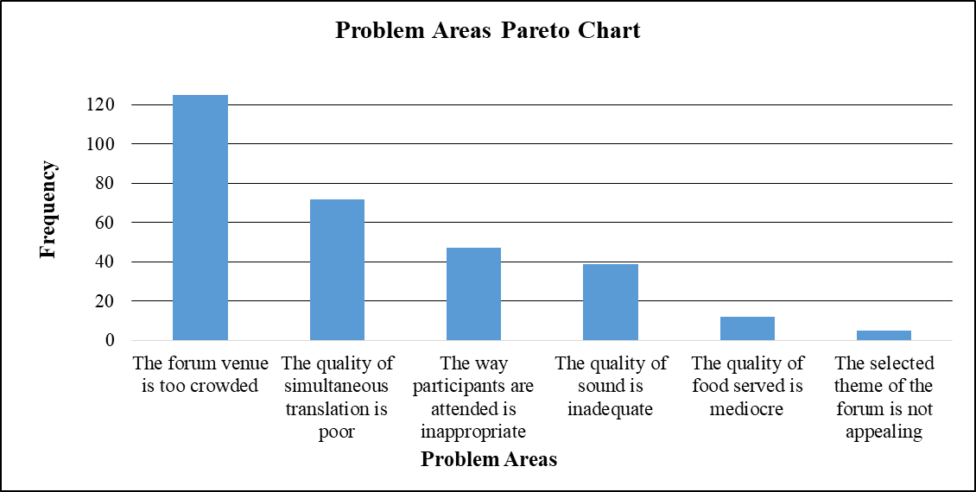
- As “The forum venue is too crowded” problem had the highest frequency amongst the other problems, THM Chairmanship decided to tackle it first. For the 9. Tourism Forum, they made arrangements with Bilkent Hotel and Conference center to use its biggest conference venue “Sakarya Ballroom”. One year later, they collected “Suggestion Cards” filled by attendees of the 9. Tourism Forum. The number of complaints as far as the venue is concerned decreased to 62. Is there any improvement as far as customers’ complaints are concerned after changing the Forum venue? If there is an improvement, what is the next problem that THM Chairmanship shall try and solve? Explain the reason behind your answer. (1 Point)
As the frequency of complaints concerning “The forum venue is too crowded” decreased from 125 to 62, there seems to be a significant improvement. Moreover, the next problem that THM Chairmanship shall try and solve is “The quality of simultaneous translation is poor”. The reason behind this approach is that this very problem received the second highest frequency (complaint wise) among the other reaons.
- Prepare a fish-bone chart for the next problem to be tackled. Come up with at least one possible cause for each category. (2 Points)

Equipment
Service Deliverer
Procedures
Attendees
Other

The answer here varies from one student to another. Hence, there is no definite set of causes. (Check students’ answers and their relevance to the problem as well as to the category in the fish-bone chart.
- Contrast “Transfer” and “Embellishment” strategies used to improve productive capacity of the service worker? (2 Points)
While “Transfer” is an approach to make knowledge available to customers so that value can be transferred with very low cost, “Embellishment” is a strategy to enhance productivity capacity.
- How can Social Media be used as a cookie-cutter presence in cyberspace? (2 Points)
The more open channels of communication a firm offers, the better a service is perceived by customers. The firms need to identify where customers go online when they have questions or feedback, and then use those to social channels to respond.
- What is “Clustered Service”? What are the major risks of such an expansion strategy? (2 Points)
Clustered service refers to an expansion strategy in which many services are offered at a single location. Moreover, the major risks of this very expansion strategy are as follows:
- Potential loss of focus.
- Neglect of the core service.
- What is “Service Offshoring”? Do you think this practice can still used in the world? Why? Why not? (3 Points)
Service offshoring refers to a global service strategy where firms send back-office activities overseas to gain labor cost savings. Such services can still be used in the world because many countries have large pools of unemployed and underemployed English-speaking educated persons many of them have high levels of technical training and can adapt to higher levels of service.
- During the past season, Yılmaz Resort Hotel did not achieve very high occupancy rates despite a reservation system that was designed to keep the hotel fully booked. Apparently, prospective guests were making reservations that, for one reason or another, they failed to honor. A review of Front-desk records during the current peak period, when the Resort Hotel was fully booked, revealed the record of no-shows as shown in the below table:
No-shows | Probability | Reservations Overbooked | Cumulative Probability
0 | 0.07 | 0 | 0.00
1 | 0.08 | 1 | 0.07
2 | 0.09 | 2 | 0.15
3 | 0.12 | 3 | 0.24
4 | 0.13 | 4 | 0.36
5 | 0.18 | 5 | 0.49
6 | 0.14 | 6 | 0.67
7 | 0.08 | 7 | 0.81
8 | 0.06 | 8 | 0.89
9 | 0.03 | 9 | 0.95
10 | 0.02 | 10 | 0.98
Suppose that a vacant room (because of No Show) results in an opportunity loss of $ 85.
- Calculate the Expected Number of No Show Rooms. (2 Points)
- Expected number of no show rooms = (0.07 * 0) + (0.08 * 1) + (0.09 * 2) + (0.12 * 3) + (0.13 * 4) + (0.18 * 5) + (0.14 * 6) + (0.08 * 7) + (0.06 * 8) + (0.03 * 9) + (0.02 * 10) = 0 + 0.08 + 0.18 + 0.36 + 0.52 + 0.90 + 0.84 + 0.56 + + 0.48 + 0.27 + 0.20 = 4.39 rooms.
- Calculate the Expected Opportunity Loss. (1 Point)
- Expected Opportunity Loss = 4.39 * 85 = $ 373.15.
In order to avoid some of this loss, Yılmaz Resort Hotel management is considering an overbooking policy. Yet, if a guest holding a reservation is turned away (due to overbooking), other costs would be incurred. Yılmaz Resort Hotel has made arrangements with a nearby Resort Hotel (Burak Resort Hotel) to pay for the rooms of guests whom it cannot accommodate. Further, a penalty is associated with the loss of customer goodwill and the impact this has on future business. Management estimates this total loss to be approximately $ 165 per turned out guest.
- Fill the below Overbooking Loss Table (4 Points)
 |  | Reservations Overbooked
No-shows | Prob. | 0 | 1 | 2 | 3 | 4 | 5 | 6 | 7 | 8 | 9 | 10
0 | 0.07 | $0 | $165 | $330 | $495 | $660 | $825 | $990 | $1,155 | $1,320 | $1,485 | $1,650
1 | 0.08 | $85 | $0 | $165 | $330 | $495 | $660 | $825 | $990 | $1,155 | $1,320 | $1,485
2 | 0.09 | $170 | $85 | $0 | $165 | $330 | $495 | $660 | $825 | $990 | $1,155 | $1,320
3 | 0.12 | $255 | $170 | $85 | $0 | $165 | $330 | $495 | $660 | $825 | $990 | $1,155
4 | 0.13 | $340 | $255 | $170 | $85 | $0 | $165 | $330 | $495 | $660 | $825 | $990
5 | 0.18 | $425 | $340 | $255 | $170 | $85 | $0 | $165 | $330 | $495 | $660 | $825
6 | 0.14 | $510 | $425 | $340 | $255 | $170 | $85 | $0 | $165 | $330 | $495 | $660
7 | 0.08 | $595 | $510 | $425 | $340 | $255 | $170 | $85 | $0 | $165 | $330 | $495
8 | 0.06 | $680 | $595 | $510 | $425 | $340 | $255 | $170 | $85 | $0 | $165 | $330
9 | 0.03 | $765 | $680 | $595 | $510 | $425 | $340 | $255 | $170 | $85 | $0 | $165
10 | 0.02 | $850 | $765 | $680 | $595 | $510 | $425 | $340 | $255 | $170 | $85 | $0
Expected | ------- | 373.15 | 305.65 | 258.15 | 233.15 | 238.15 | 275.65 | 358.15 | 475.65 | 613.15 | 765.65 | 925.65
Loss ($)
- How many rooms shall be overbooked? Why? (2 Points)
According to the above overbooking loss table, 3 rooms shall be overbooked, since, this very scenario yields the least expected loss.
N.B: Your answers to parts a), b) c) & d) shall be rounded to the nearest cent.
- Briefly explain how developing complementary services levels capacity. Provide 1 example clarifying this point. (2 Points)
Developing complementary services is launching other products / services to be provided with the primary or core product / service. If this is planned appropriately (for example, demand complementary service shall be contra-cyclical to the demand of the core service), the result is a more uniform aggregate demand. Some examples of complementary services could be as follows:
- Restaurants adding a bar.
- Movie theaters selling popcorn and soft drinks in addition to installation of video game machines.
Good Luck

